Tool Support for Testing

🔹 Definition
# Source: AI Source: Provided by: [Data Path: Persons Table -> ID Column: 1, Name_En Column: Motasem Essam] -> From: [ChatGPT] on [8/25/2025]
Tool Support for Testing means using software tools to help with different testing activities (planning, designing, executing, monitoring, reporting, etc.) instead of doing everything manually.

🔧 Tool Support for Testing – Categories

1. Test Management Tools
# Source: AI Source: Provided by: [Data Path: Persons Table -> ID Column: 1, Name_En Column: Motasem Essam] -> From: [ChatGPT] on [8/25/2025]
- Help in planning, organizing, and controlling test activities.
- Features: test case creation, scheduling, execution tracking, defect linkage, reporting.
- Examples: Jira + Xray, TestRail, Zephyr, qTest.

2. Test Design Tools
# Source: AI Source: Provided by: [Data Path: Persons Table -> ID Column: 1, Name_En Column: Motasem Essam] -> From: [ChatGPT] on [8/25/2025]
- Assist in creating test conditions, cases, and data.
- Can generate test cases automatically based on models or requirements.
- Examples: Conformiq, Test Modeler, Hexawise.

3. Test Data Preparation Tools
# Source: AI Source: Provided by: [Data Path: Persons Table -> ID Column: 1, Name_En Column: Motasem Essam] -> From: [ChatGPT] on [8/25/2025]
- Create, generate, mask, or manage test data.
- Useful for sensitive data compliance (e.g., GDPR).
- Examples: Informatica TDM, Delphix, IBM Optim.

4. Test Execution Tools (Automation Tools)
# Source: AI Source: Provided by: [Data Path: Persons Table -> ID Column: 1, Name_En Column: Motasem Essam] -> From: [ChatGPT] on [8/25/2025]
- Execute tests automatically and compare actual vs. expected results.
- Reduce manual effort and speed up regression testing.
- Examples: Selenium, Cypress, Playwright, Appium, UFT.

5. Performance Testing Tools
# Source: AI Source: Provided by: [Data Path: Persons Table -> ID Column: 1, Name_En Column: Motasem Essam] -> From: [ChatGPT] on [8/25/2025]
- Measure speed, scalability, stability, and responsiveness of applications.
- Examples: JMeter, LoadRunner, Gatling, Locust.

6. Static Analysis Tools
# Source: AI Source: Provided by: [Data Path: Persons Table -> ID Column: 1, Name_En Column: Motasem Essam] -> From: [ChatGPT] on [8/25/2025]
- Analyze code without executing it.
- Help detect coding standards violations, security flaws, vulnerabilities.
- Examples: SonarQube, Coverity, Fortify.

7. Defect Management Tools
# Source: AI Source: Provided by: [Data Path: Persons Table -> ID Column: 1, Name_En Column: Motasem Essam] -> From: [ChatGPT] on [8/25/2025]
- Help in logging, tracking, prioritizing, and closing defects.
- Examples: Jira, Bugzilla, MantisBT.

8. Continuous Integration & Delivery (CI/CD) Tools
# Source: AI Source: Provided by: [Data Path: Persons Table -> ID Column: 1, Name_En Column: Motasem Essam] -> From: [ChatGPT] on [8/25/2025]
- Support automated builds, integration, and test execution in pipelines.
- Examples: Jenkins, GitLab CI, Azure DevOps, Bamboo.

9. Monitoring & Test Environment Tools
# Source: AI Source: Provided by: [Data Path: Persons Table -> ID Column: 1, Name_En Column: Motasem Essam] -> From: [ChatGPT] on [8/25/2025]
- Monitor system behavior in real-time during or after testing.
- Manage configurations, environments, and deployments.
- Examples: Dynatrace, New Relic, Docker, Kubernetes.

✅ Benefits of Tool Support
# Source: AI Source: Provided by: [Data Path: Persons Table -> ID Column: 1, Name_En Column: Motasem Essam] -> From: [ChatGPT] on [8/25/2025]
- Faster and more accurate execution.
- Improves test coverage.
- Enhances traceability between requirements, tests, and defects.
- Enables CI/CD and Agile/DevOps testing.
- Better collaboration and reporting.

⚠️ Note: Tools don’t replace testers. They support testing activities but still need human judgment for test design, risk analysis, and understanding business needs.

🗂️ Tool Support for Testing – Mapping Table
# Source: AI Source: Provided by: [Data Path: Persons Table -> ID Column: 1, Name_En Column: Motasem Essam] -> From: [ChatGPT] on [8/25/2025]
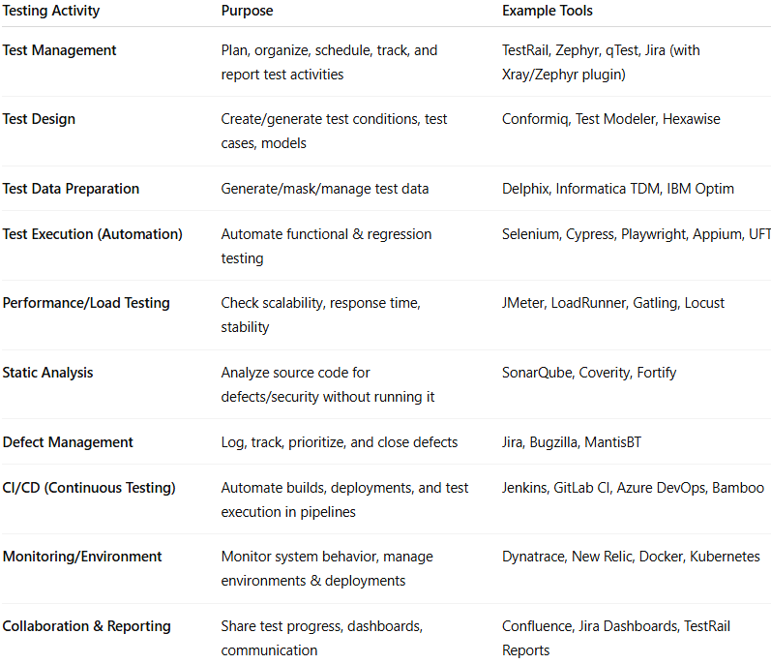

Testing Activity | Purpose | Example Tools
Test Management | Plan, organize, schedule, track, and report test activities | TestRail, Zephyr, qTest, Jira (with Xray/Zephyr plugin)
Test Design | Create/generate test conditions, test cases, models | Conformiq, Test Modeler, Hexawise
Test Data Preparation | Generate/mask/manage test data | Delphix, Informatica TDM, IBM Optim
Test Execution (Automation) | Automate functional & regression testing | Selenium, Cypress, Playwright, Appium, UFT
Performance/Load Testing | Check scalability, response time, stability | JMeter, LoadRunner, Gatling, Locust
Static Analysis | Analyze source code for defects/security without running it | SonarQube, Coverity, Fortify
Defect Management | Log, track, prioritize, and close defects | Jira, Bugzilla, MantisBT
CI/CD (Continuous Testing) | Automate builds, deployments, and test execution in pipelines | Jenkins, GitLab CI, Azure DevOps, Bamboo
Monitoring/Environment | Monitor system behavior, manage environments & deployments | Dynatrace, New Relic, Docker, Kubernetes
Collaboration & Reporting | Share test progress, dashboards, communication | Confluence, Jira Dashboards, TestRail Reports

✅ Quick Insight:
- Test Management tools = “control room” of testing.
- Automation tools = “execution engine”.
- Performance tools = “stress testers”.
- Defect tools = “tracking system”.
- CI/CD tools = “DevOps enablers”.

Testing Workflow with Tool Support
# Source: AI Source: Provided by: [Data Path: Persons Table -> ID Column: 1, Name_En Column: Motasem Essam] -> From: [ChatGPT] on [8/25/2025]
Perfect 👌 Let’s visualize how testing tools fit together in a real testing workflow. I’ll describe it step by step like a flow diagram:
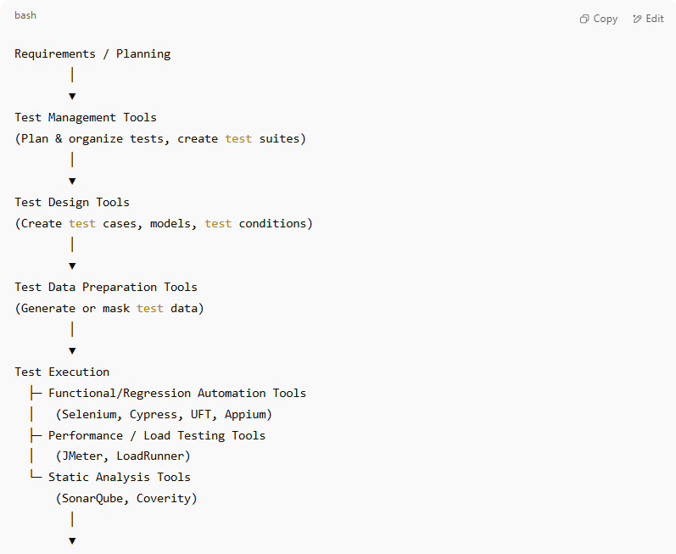
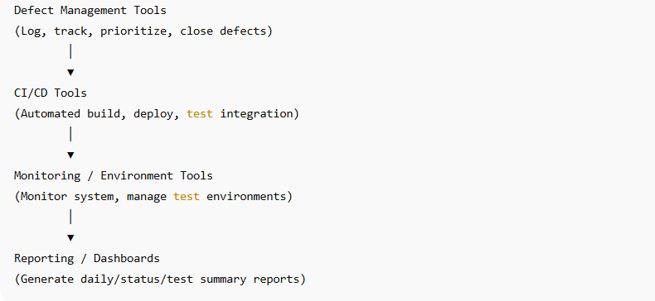
Requirements / Planning
│
▼
Test Management Tools
(Plan & organize tests, create test suites)
│
▼
Test Design Tools
(Create test cases, models, test conditions)
│
▼
Test Data Preparation Tools
(Generate or mask test data)
│
▼
Test Execution
├─ Functional/Regression Automation Tools
│ (Selenium, Cypress, UFT, Appium)
├─ Performance / Load Testing Tools
│ (JMeter, LoadRunner)
└─ Static Analysis Tools
(SonarQube, Coverity)
│
▼
Defect Management Tools
(Log, track, prioritize, close defects)
│
▼
CI/CD Tools
(Automated build, deploy, test integration)
│
▼
Monitoring / Environment Tools
(Monitor system, manage test environments)
│
▼
Reporting / Dashboards
(Generate daily/status/test summary reports)

🔹 Explanation
# Source: AI Source: Provided by: [Data Path: Persons Table -> ID Column: 1, Name_En Column: Motasem Essam] -> From: [ChatGPT] on [8/25/2025]
- Planning: Use Test Management tools to organize tests.
- Design: Create cases and conditions using Test Design tools.
- Data Prep: Generate valid data with Test Data tools.
- Execution: Run tests via Automation tools, performance testing, or static analysis.
- Defect Management: Log and track defects in tools like Jira.
- CI/CD Integration: Automate builds and test execution in pipelines.
- Monitoring: Track system performance and environment stability.
- Reporting: Use dashboards for test progress, defects, and quality metrics.

✅ Key Insight:
All tools work together to create a continuous, traceable, and efficient testing process, ensuring better software quality with less manual effort.

